**English Language 1**

**Second Homework: *“Description of hardware”***

[**Motherboard**](https://en.wikipedia.org/wiki/Motherboard)

Motherboard, also referred to as mainboard, base board, main circuit board, etc. is the main printed circuit board [PCB] of any computer or expandable system. Its purpose is to hold and allow communication between essential electronic components of a system ([Central Processing Unit](https://en.wikipedia.org/wiki/Central_processing_unit), [Memory](https://en.wikipedia.org/wiki/Computer_memory), [I/O devices](https://en.wikipedia.org/wiki/Input/output)).

This piece of hardware represents the skeleton of a computer and generally, it’s just a flat printed circuit board varying in size between the size of a small book to a serving dish, with its thickness of roughly 0.5mm. Most commonly with a rectangular shape, this board is a suite of connectors, slots and ports for different hardware parts.

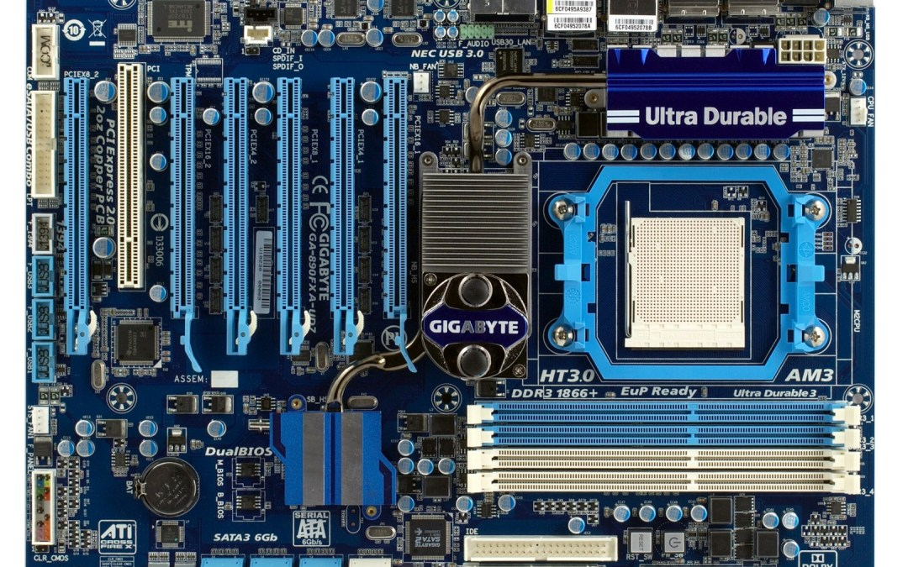The most important part of the mainboard is its processor, or generally, a socket for one. This socket only accommodates a certain type of processor, because not every processor has the same dimensions, or shape.

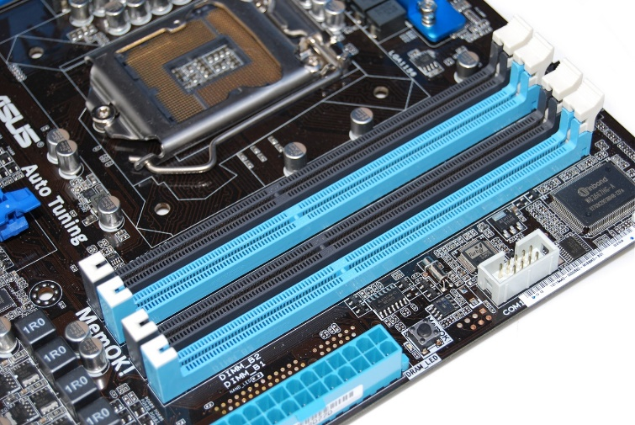On the photo above we can see that the shown motherboard has a rectangular shape, the most noticeable thing is of course the previously mentioned socket for a processor. It’s a rectangular [perforated metal](https://en.wikipedia.org/wiki/Perforated_metal) located on the middle right side of the mainboard, and surrounded with a blue metal in a shape of an octagon with two screws on its left and right sides.

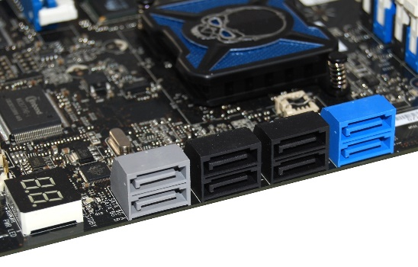We can also visually differentiate RAM and SATA ports.

Ram ports, are elongated cuboids with a hollowed out middle and top part with a small space for [Random Access Memory](https://en.wikipedia.org/wiki/Random-access_memory) cards to slide into the place.

[SATA](https://en.wikipedia.org/wiki/Serial_ATA) ports, used to connect mass storage devices (hard disk drives, optical drives, solid state drives), are located on the left side of the motherboard. These ports have a cuboid-like shape, they are divided in half and each half has a rotated “L” shape inside of it.